**Step for STM32F446RE Led Blinking**

1. Download STM32CubeIDE (version 1.6.1) from <https://www.st.com/en/development-tools/stm32cubeide.html#get-software>.
2. Click File -> New -> STM32 Project to start a new project.
3. In STM32 Project pop out window, in MCU/MPU Selector tab type “STM32F446RE” in Part Number to search the board to be used and the click next.
4. In next window, type the project name and use the default setting, after that click “Finish”.
5. In the “Open Associated Perspective?” window, click “Yes”. Wait for the software package finish downloading.
6. In “Pinout & Configuration”, left click on PA5 and choose as GPIO_Output.
7. In “Project”, click “Generate Code”.
8. In the while loop, type the led blinking code.

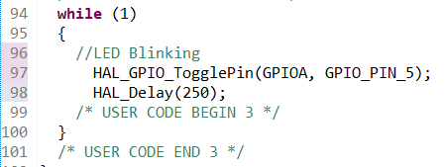

1. Click on hammer icon to build “Debug” for project.
2. Ensure zero error and click Play button to run main.c.
3. In the pop out window, remain the default setting and click “OK”.

Github account Username

Chan Jia Zhen -> CJZhen96

Chung Wei Hong -> chungweihong